PF LAB 12 Tasks:
Task#6:
#include <stdio.h>

int main() {
int *ptr;
*ptr = 10;
printf("%d\n", *ptr);
return 0;
}
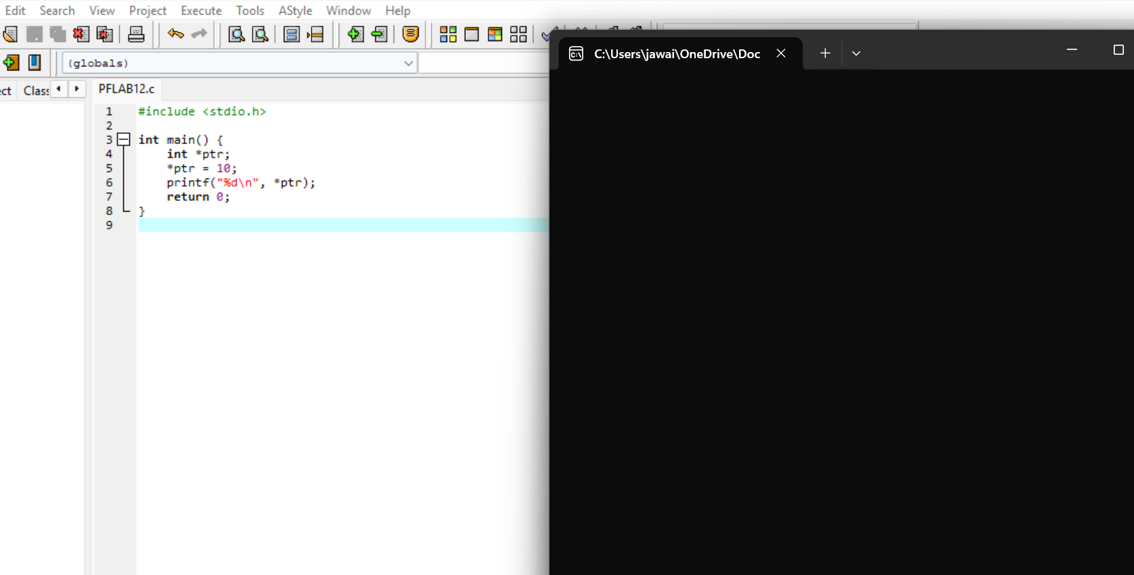

Task#7:
#include <stdio.h>
#include <stdlib.h>

int main() {
int *ptr;
ptr = (int*)malloc(5 * sizeof(int));

if(ptr == NULL) {
printf("Memory allocation failed\n");
return 1;
}
int i;
for(i = 0; i < 5; i++) {
ptr[i] = i + 1;
}

int *new_ptr;
new_ptr = (int*)realloc(NULL, 10 * sizeof(int));

if(new_ptr == NULL) {
printf("Reallocation failed\n");
free(ptr);
return 1;
}

for(i = 0; i < 10; i++) {
printf("%d ", new_ptr[i]);
}

free(ptr);
free(new_ptr);
return 0;
}
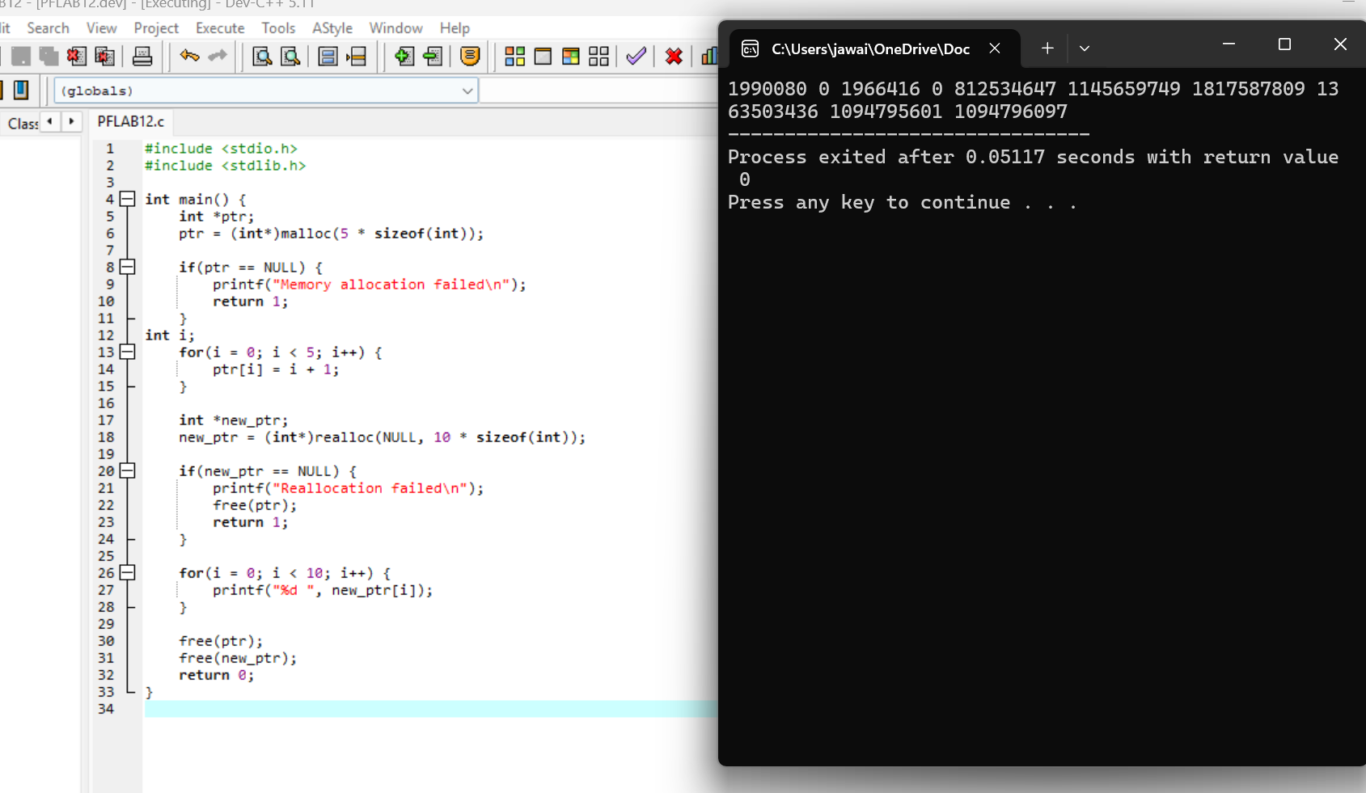

Task#8:
#include <stdio.h>
#include <stdlib.h>

int main() {
int *arr;
int i;
arr = (int*)malloc(10 * sizeof(int));

for(i = 0; i < 10; i++) {
arr[i] = i + 1;
}

for(i = 0; i < 10; i++) {
printf("%d ", arr[i]);
}
printf("\n");

for(i = 0; i < 10; i++) {
arr[i] = arr[i] * 2;
}

for(i = 0; i < 10; i++) {
printf("%d ", arr[i]);
}
printf("\n");

return 0;
}
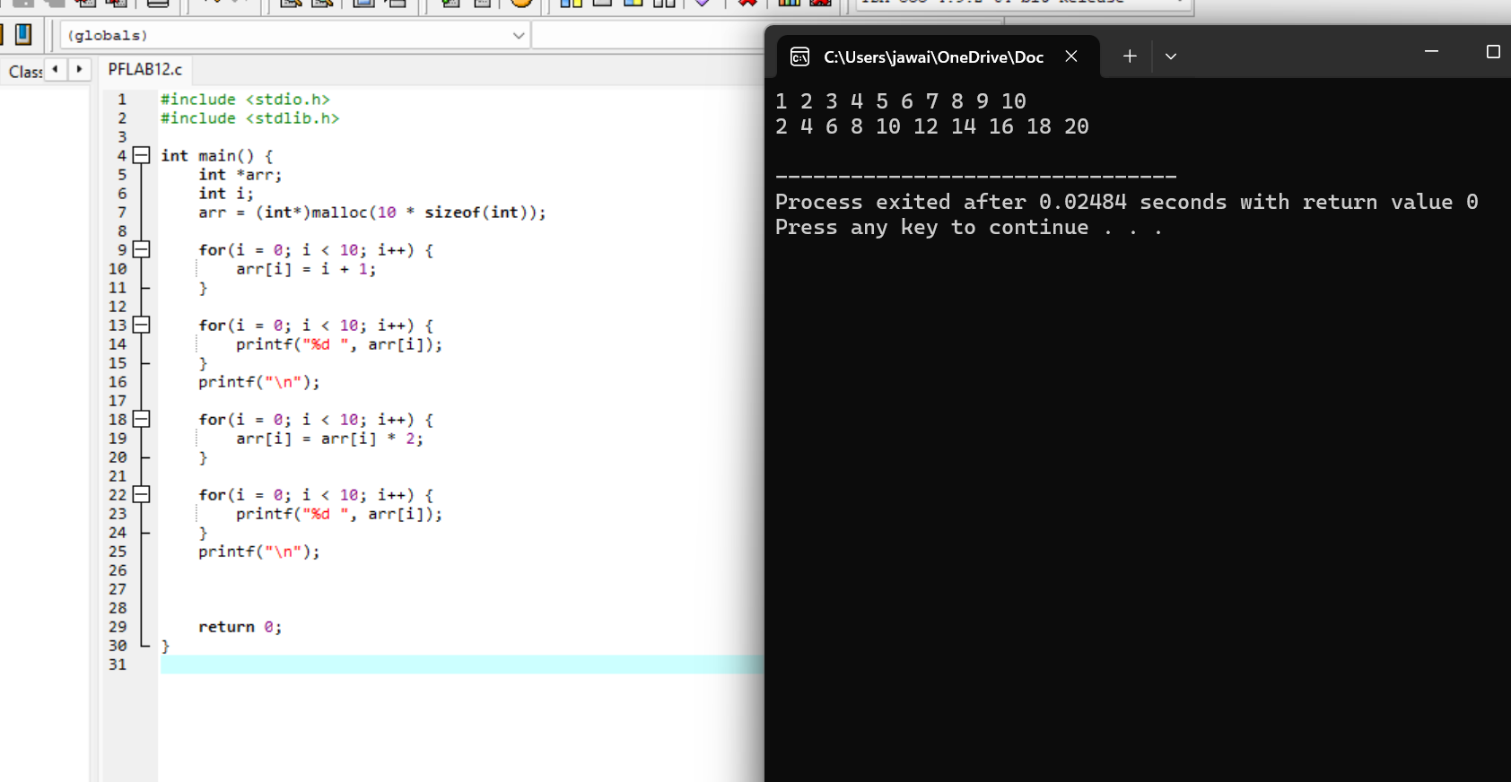

Task#9:
#include <stdio.h>
#include <stdlib.h>

int main() {
int n;
int *arr;
int i;

printf("Enter number of integers: ");
scanf("%d", &n);

arr = (int*)malloc(n);

for(i = 0; i < n; i++) {
arr[i] = i + 1;
}

for(i = 0; i < n; i++) {
printf("%d ", arr[i]);
}
printf("\n");

free(arr);
return 0;
}

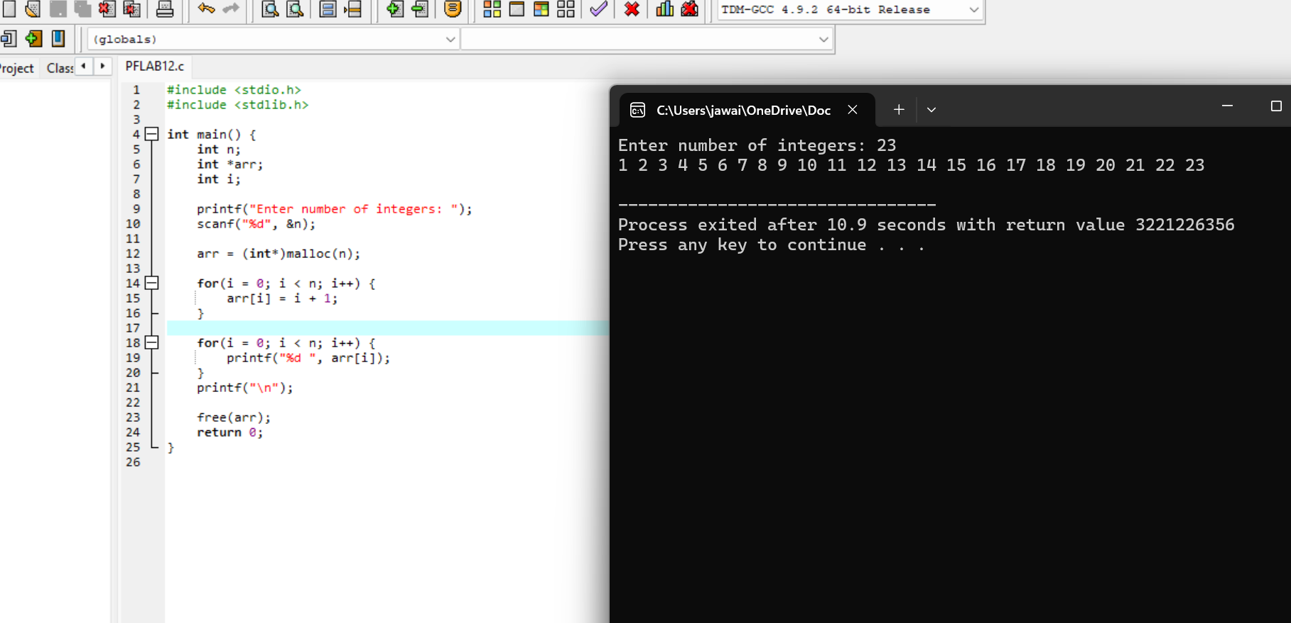

Task#10:
#include <stdio.h>
#include <stdlib.h>

int main() {
int *ptr;
int i;

ptr = (int*)malloc(5 * sizeof(int));

for(i = 0; i < 5; i++) {
ptr[i] = i + 1;
}

int *new_ptr;
new_ptr = (int*)realloc(ptr, 10 * sizeof(int));

free(ptr);

printf("Trying to access old pointer after free:\n");
for(i = 0; i < 10; i++) {
printf("%d ", ptr[i]);
}
printf("\n");

free(new_ptr);

return 0;
}

